**Exploratory Analysis of Food.com Recipe Scrape**

Joshua Grou, Jason Bauer

**Dataset**

The project of creating a personal chef cognitive assistant will need a large amount of data around what ingredients go with what recipes in order to serve accurate recommendations for recipes to create with the users on hand ingredients. To serve this goal a dataset was found that contains ingredient lists and other metadata for over 230K recipes taken from food.com. This dataset was sourced from Kaggle. The dataset contains twelve columns displayed below. There are a few columns that may be of particular interest to this project. The name column contains a string with the name of the recipe, similarly the description column contains a string describing the recipe. The ingredients column contains a list of ingredients required to make the recipe and the n_ingredients column counts that list. Similarly the steps and n_steps column contain the number and description of steps needed to make the dish. The tags and nutrition column may be interesting to explore as some of the tags indicate time expectation and the nutrition column may be utilized to cater to specific dietary needs. The following analysis will mostly be focused on the ingredients column as utilizing this column will be essential to building the personal chef cognitive assistant.

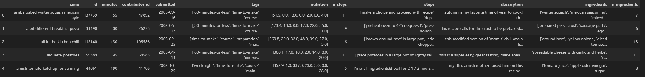

**Analysis of Ingredients**

The ingredients column was first analyzed to understand what types of ingredients are utilized heavily or any trends that may pose some challenges. First the column was cleaned and frequency of ingredients was counted. The top 20 ingredients were plotted as shown below.

By far the most common ingredient was salt, appearing in over 80K recipes. This also uncovered some problems with the dataset that will need to be addressed. The obvious problem is that certain ingredients are duplicated such as salt, pepper, and salt and pepper, egg and eggs, garlic cloves and garlic. This presents a challenge as for instance if a user tells the application that they have garlic it is likely that the recipes containing garlic cloves should not be excluded from the search. A slightly less obvious challenge may be that users might not recognize certain ingredients as recipe components, for instance salt is something that is present in every kitchen and thus users may not explicitly tell the application that they have salt but again recipes containing salt likely should not be excluded unless the user has identified some dietary restriction around salt.

The distribution of the number of ingredients in a recipe was also investigated as shown below. This distribution is centered on approximately 8 ingredients per recipe with an extended right sided tail.

This indicates that most recipes do not have an extensive collection of ingredients, and from the earlier analysis on frequency of ingredients it is likely that most recipes also contain at least one “staple” ingredient that users probably have already. This is likely a positive indication for the personal chef cognitive assistant as recipes that have less ingredients with some staples are more likely to be able to be made by what a user already has in their home.

Following the analysis of the ingredient frequency investigation on the correlation with other variables was done. This returned a perhaps expected finding that the number of ingredients is weakly positively correlated with the number of steps for the recipe indicating that in general the more ingredients that a recipe contains. This could be useful in recommending recipes if for instance a user indicates that they are looking for something simple to make a lower ingredient count recipe will in general yield a recipe with less steps to complete.

**Analysis of Tags Column**

Similar to the ingredients column the frequency of tags was analyzed to uncover any popular tags and trends that could be utilized in recommendation. The result of this frequency counting is shown below.

Here its seen that many of the recipes have tags describing the approximate preparation time, what course it is (entrée, desert or appetizer) as well as the type of cuisine that it comes from. These could potentially be utilized by the cognitive application to further tailor recipe recommendations for a particular user.

**Analysis of Number of Steps Column**

The distribution of number of steps was analyzed and after creating a histogram of the available data it was determined that the majority of the data has a number of steps less than 20 however, there is an extremely long right sided tail. This right sided tail could potentially be coming from an error in the dataset as it seems unlikely that anyone would cook or post a recipe containing over 100 steps.

The distribution of steps tending toward the lower side could be helpful for personal chef cognitive assistant as many users could potentially be looking for quick to make meals which involve less steps. This is also convenient in that if generative AI is employed lengthy recipes may overwhelm the token limit of the model rendering it unable to effectively communicate with the user.